Angle of reflection

A ray of light reflects off a flat mirror. It reflects in just one direction.
It reflects at the angle of reflection.
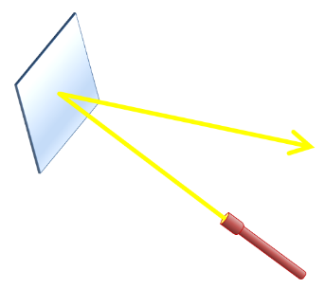

Which picture shows the angle of reflection?
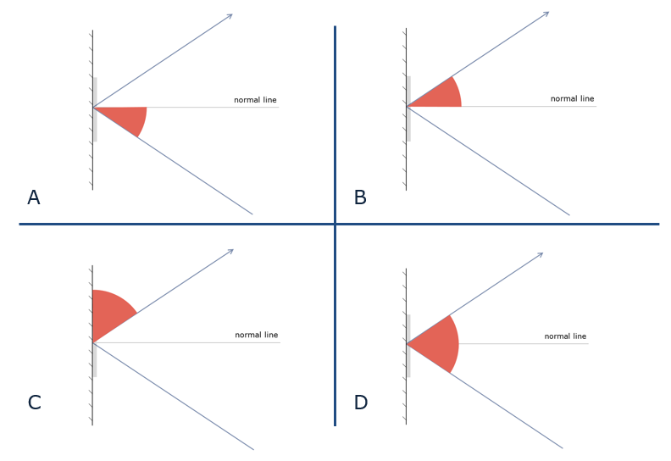

Physics > Big idea PSL: Sound, light and waves > Topic PSL1: Sound and light > Key concept PSL1.2: Characteristics of light
Diagnostic question
Angle of reflection

Overview
Learning focus: | Light is reflected from all surfaces, and off a flat mirror it is reflected in a single direction.
Observable learning outcome: | Draw a ray diagram to show how light reflects off a flat mirror.
Question type: | Simple multiple choice
Key words: | Reflect, angle of reflection, normal

What does the research say?
Anecdotal evidence suggests significant numbers of students continue to mix up which angle is which in ray diagrams. This question identifies which angle students think is the angle of reflection.
Ways to use this question
Students should complete the question individually. This could be a pencil and paper exercise, or you could use an electronic ‘voting system’ or mini white boards and the PowerPoint presentation.
The answers to the question will show you whether students understood the concept sufficiently well to apply it correctly.
If there is a range of answers, you may choose to respond through structured class discussion. Ask one student to explain why they gave the answer they did; ask another student to explain why they agree with them; ask another to explain why they disagree, and so on. This sort of discussion gives students the opportunity to explore their thinking and for you to really understand their learning needs.
Differentiation
You may choose to read the questions to the class, so that everyone can focus on the science. In some situations it may be more appropriate for a teaching assistant to read for one or two students.
Expected answer
B
How to respond - what next?
Answer C is often the most common error because this makes the most sense to many students.
The correct angle is measured from the normal line so that it can be measured in the same way when the mirror is curved. (The normal is the line drawn at right angles to the tangent of the curve at the point the ray of light hits the mirror.)
If students have confusion about which angle is the angle of reflection, then this can be made clear and reinforced through short teaching and learning activities repeated over several lessons.
The following BEST ‘response activity’ could be used in follow-up to this diagnostic question:
- Response activity: Reflecting angles
Acknowledgments
Developed by Peter Fairhurst (UYSEG).
Images: UYSEG

